EX. NO: 1 : IMPLEMENTATION OF CAESAR CIPHER

AIM: To implement the simple substitution technique named Caesar cipher using C language.

DESCRIPTION:
To encrypt a message with a Caesar cipher, each letter in the message is changed
using a simple rule: shift by three. Each letter is replaced by the letter three letters ahead in the alphabet. A becomes D, B becomes E, and so on. For the last letters, we can think of alphabet as a circle and "wrap around". W becomes Z, X becomes A, Y becomes B, and Z becomes C. To change a message back, each letter is replaced by the one three before it.

EXAMPLE:

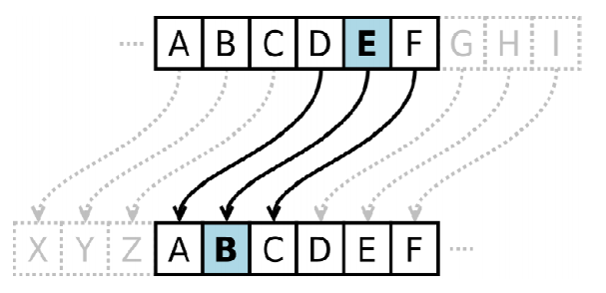

ALGORITHM:

STEP-1: Read the plain text from the user.
STEP-2: Read the key value from the user.
STEP-3: If the key is positive then encrypt the text by adding the key with each
character in the plain text.
STEP-4: Else subtract the key from the plain text.
STEP-5: Display the cipher text obtained above

PROGRAM: (Caesar Cipher)

#include <stdio.h>
#include <string.h>
#include <ctype.h>
void main()

{
char plain[10], cipher[10];
int key,i,length;
int result;
printf("\n Enter the plain text:");
scanf("%s", plain);
printf("\n Enter the key value:");
scanf("%d", &key);
printf("\n \n \t PLAIN TEXt: %s",plain);
printf("\n \n \t ENCRYPTED TEXT: ");
for(i = 0, length = strlen(plain); i < length; i++)
{
cipher[i]=plain[i] + key;
if (isupper(plain[i]) && (cipher[i] > 'Z'))
cipher[i] = cipher[i] - 26;
if (islower(plain[i]) && (cipher[i] > 'z'))
cipher[i] = cipher[i] - 26;
printf("%c", cipher[i]);
}
printf("\n \n \t AFTER DECRYPTION : ");
for(i=0;i<length;i++)
{
plain[i]=cipher[i]-key;
if(isupper(cipher[i])&&(plain[i]<'A'))
plain[i]=plain[i]+26;
if(islower(cipher[i])&&(plain[i]<'a'))
plain[i]=plain[i]+26;
printf("%c",plain[i]);
}
getch();
}

OUTPUT:

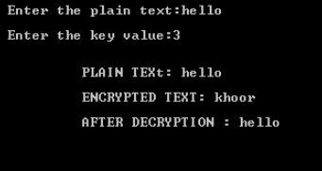

RESULT:
Thus the implementation of Caesar cipher had been executed successfully.

Case study on the indicators for verifying TLS/SSL connections over HTTPS on a website

SSL and TLS are used for two primary purposes:

1. Authentication of the server that a client is communicating with.
2. Encrypting data sent between the client and the server.

When a user loads a website in his/her browser that should be protected with HTTPS (and subsequently SSL or TLS), that browser is actually only confirming that the system it is communicating with is providing a certificate that is issued by one of the root CAs that the browser trusts. We are implicitly trusting that each root CA has done its work to verify the identity of the server that you are connecting to. Sometimes root CAs get tricked, we are also
trusting that each root CA has taken the appropriate steps to protect its own systems.

Site Security Indicators:
Most websites utilize HTTPS to conduct secure transactions with their customers to send sensitive information such as credit numbers, purchase records or personal information. For example, here we have considered Vijaya Bank website for SSL connection. The login pages of banking site and the check-out pages of most e-commerce site are implemented using HTTPS.

Users can verify web sites by recognizing site security indicators. They are the indicators for verifying TLS/SSL connections over HTTPS on a web site. These indicators only are displayed when a TLS/SSL session is established between a browser and the web server.

The indicators included the following:
• HTTPS heading in this URL that indicates a HTTPS session is established.
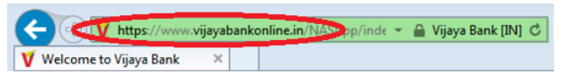
• SSL security padlock at the upper left corner of the browser following the domain name of the secure web server. The domain name of this bank mentioned should be the same as the one in the URL. By double clicking the padlock, users will be able to see the contents of the digital certificate for the Vijay bank web server.
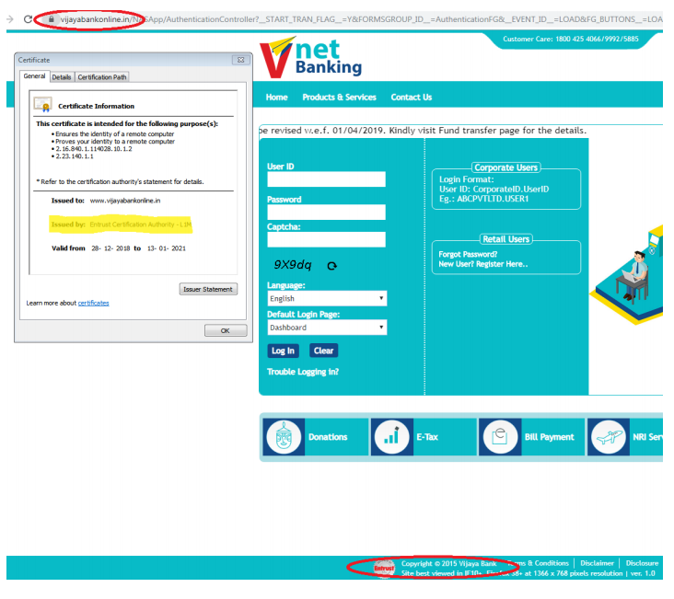

Security seal which is an icon that links to the site‘s certificate issuer, such as Entrust. Once users click on the security seal, they will be prompted with certificate information to verify the web site that displays the seal. A security seal is an additional indicator for users to authenticate the server although the website is verified by just the HTTPS heading and the SSL security padlock.

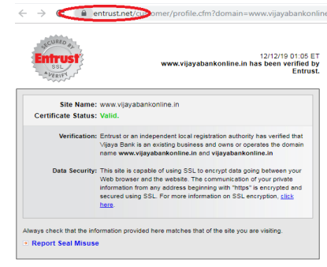

Digital certificate:
Digital certificate is a cryptographic method used in TLS/SSL to authenticate both parties of a communication. When a browser is connecting to a web server requesting a TLS/SSL session, the server sends the browser its digital certificate and the browser then verifies the certificate using the public key of the certificate issuer that has been pre-installed in the browser. If the certificate is accepted, the TLS/SSL session is established.
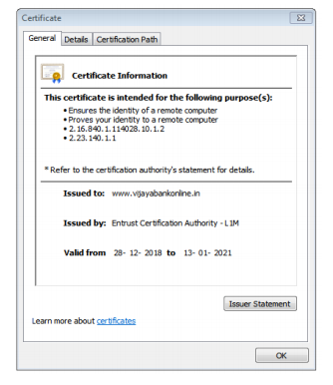
A digital certificate contains information for site validation including:

• Common name: It is the server domain name displayed in the certificate. Once a certificate is received, browsers compare the common name with the domain name in the URL. If they do not match, it is likely that the certificate is forged and a warning window would pop up to warn users of the potential risk. The attacker might try to steal the important information that the user enters. Here is an example of Vijaya Bank where the website is not trusted.

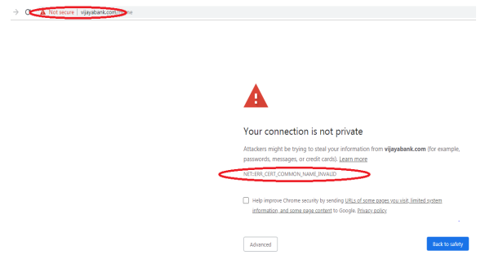

Organization name: Each certificate displays the name of the organization that operates the server. The organization name usually is the same as the company name on the web site.
However, there are a couple of reasons that the organization name could be different. First, the organization who registers for the certificate is the holding company. Second, companies may outsource its web services to a third party who operates the web server.
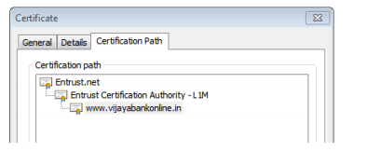

Cipher suite: The cryptographic method used to secure the transaction, which include the key size, the hash function used, the authentication and digital signature cipher and a symmetric key encryption method. Since a browser usually advertises several cipher suites, the web server picks the strongest one it can offer. In our survey, we advertised all cipher suites that are currently available on the website so that we could know the strongest cipher suite that the banking web server adopts.

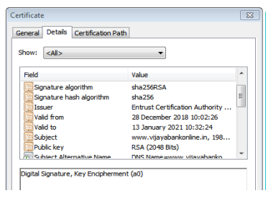
SSL version: The most current SSL version is TLSv1 although SSLv3 or SSLv2 are still used by some web servers. SSLv2 and SSLv3 have been proved to have several security vulnerabilities.
• Validity duration: The number of years that the digital certificate is valid.

Sites inspection for validation of certificates:

The ‗’s‘ in the URL‘s HTTP protocol stands for ‗secure‘ and notifies users that the site is encrypted with an SSL certificate. Depending on the type of the certificate, there are also other visual clues that refer to secure encryptions:

